**9.8 Volume IB Problem Set**

1. A right pyramid has apex  and rectangular base , with ,  and . The vertical height of the pyramid is .
2. *[4 marks]* 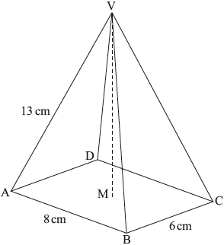Calculate .

b) *[2 marks]* Calculate the volume of the pyramid.

**2a.**

A child’s wooden toy consists of a hemisphere, of radius 9 cm , attached to a cone with the same base radius. O is the centre of the base of the cone and V is vertically above O.

Angle OVB is .

***Diagram not to scale.***

1. 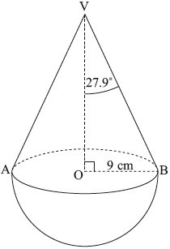*[2 marks]* Calculate OV, the height of the cone.
2. *[4 marks]* Calculate the volume of wood used to make the toy.

**3a.** *[6 marks]* The following diagram shows a perfume bottle made up of a cylinder and a cone. The radius of both the cylinder and the base of the cone is 3 cm. The height of the cylinder is 4.5 cm. The slant height of the cone is 4 cm.

1. 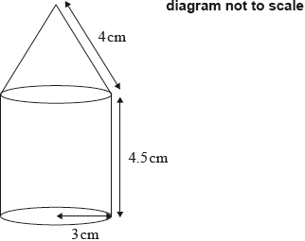 Show that the vertical height of the cone is  cm correct to three significant figures.
2. Calculate the volume of the perfume bottle.

**3b.** *[2 marks]* The bottle contains  of perfume. The bottle is **not** full and all of the perfume is in the cylinder part. Find the height of the perfume in the bottle.

**3c.** *[4 marks]* Temi makes some crafts with perfume bottles, like the one above, once they are empty. Temi wants to know the surface area of one perfume bottle. Find the **total** surface area of the perfume bottle.

**3d.** *[4 marks]* Temi covers the perfume bottles with a paint that costs 3 South African rand (ZAR) per millilitre. One millilitre of this paint covers an area of . Calculate the cost, in ZAR, of painting the perfume bottle. **Give your answer correct to two decimal places**.

**3e.** *[2 marks]* Temi sells her perfume bottles in a craft fair for 325 ZAR each. Dominique from France buys one and wants to know how much she has spent, in euros (EUR). The exchange rate is 1 EUR = 13.03 ZAR. Find the price, in EUR, that Dominique paid for the perfume bottle. **Give your answer correct to two decimal places**.

**9.8 Mixed Regents Problems**

*Draw a picture and show work to receive full credit*

1. 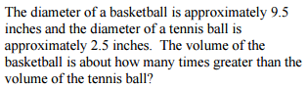

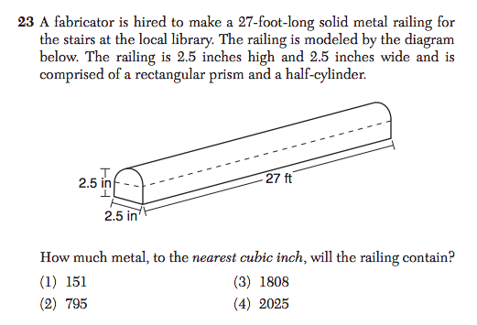

3.   
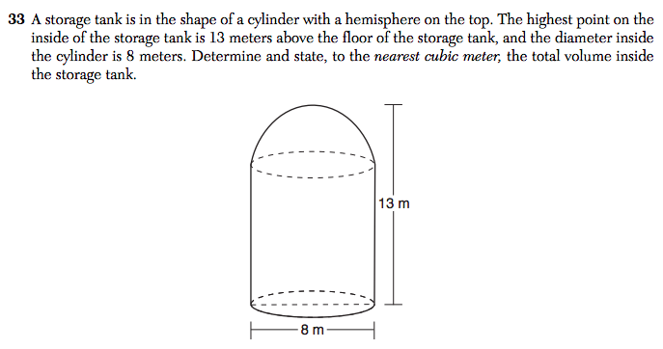

4.   
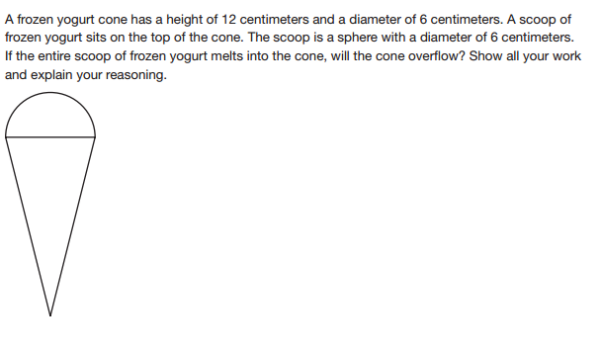

5.

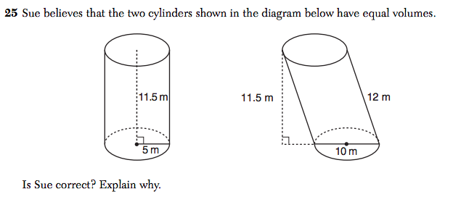

6.   
